**A 3D Chess Set**

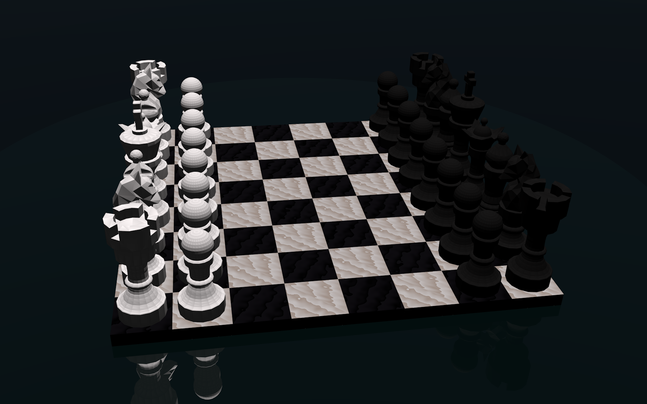

By Roman S. Collins

Course: 3D Modeling Seminar

05/05/2017

For my 3D modeling final I decided to model a full chess set. With time saving techniques demonstrated by using the screw modifier tool, convert to mesh, edit mode, and a few others, I was able to model the complete set of pieces I hope to later print. The group of objects I have created can also be used to render images like Figure 1.

The most time consuming part of the process was making the individual pieces themselves. Pieces like the pawn, rook, and queen were the easiest as they are symmetrical. Others such as the knight, bishop, and king were more difficult. Knight being the least symmetrical of all of the shapes.

To make each piece I started by changing the viewing mode to ortho linear (numpad 5). I then selected the background image within the 3D view pane of the Blender window. Making sure that the piece I was about to model was centered to the grid. I used the Blender add-on "Add Mesh: Extra Objects" to create single vertices in object mode, tracing around the symmetrical parts of the chess piece. For the pawn it's the entire object. For the knight it's only the pedestal that the horse sits on. After tracing one side of the chess piece by adding a single vertex then extruding vertices all the way down I change to object mode and apply the screw modifier from the modifier properties tab. (Right pane) after applying the screw modifier I clicked on the object button at the bottom of 3d view, selected convert to, and mesh from curve. Which creates a 3D mesh from the object made by using the screw tool. In edit mode I check the bottom and top of the model for holes.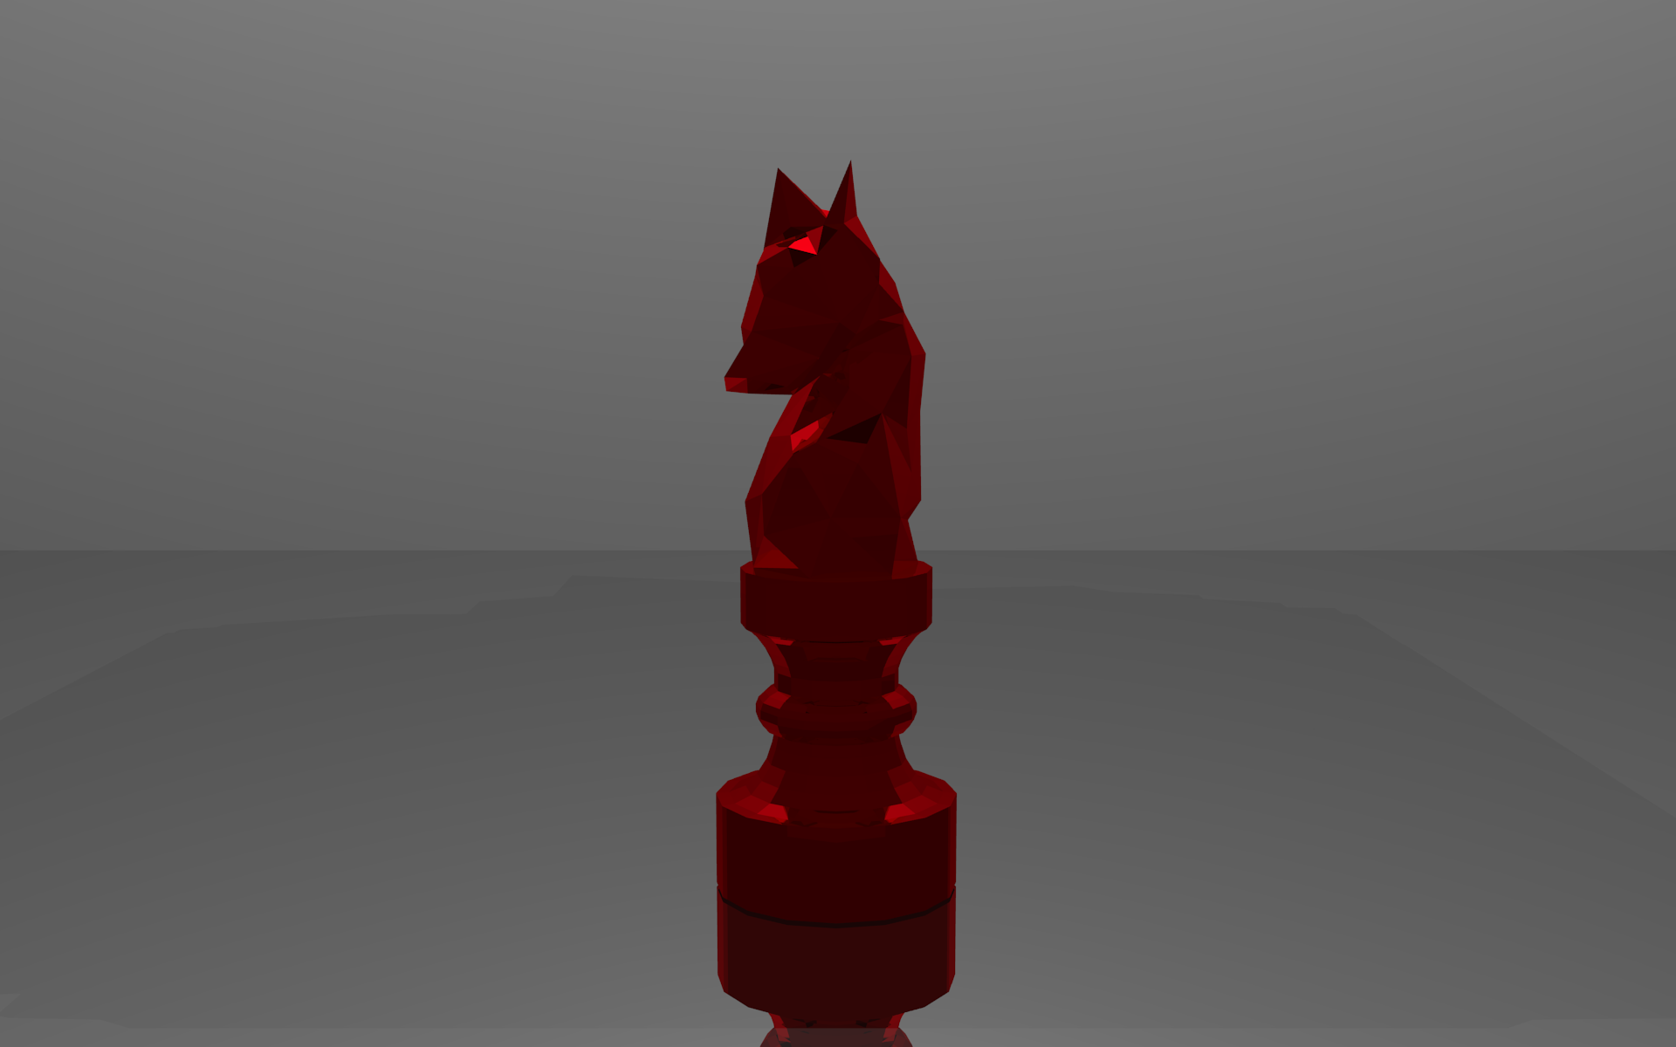

For the asymmetrical portions of each chess piece instead of starting with single vertices when tracing I started with a cylinder making sure that it is centered along the x and y axis. I switch back into ortho linear view mode and begin extruding the cylinder up scaling each extrusion to the outline of my reference image.

After the cylinder matches the height and width tracing my reference I scaled the each extrusion along the y axis so that it begins to look like a 3D version of my reference. A horse head for the knight chess piece for example. For the horse I using the decimate modifier and pulled out two vertices to form the ears. I spun the model around on the z axis pulling in and pushing out individual vertices while repairing holes in the model until it took the shape of a horse.

For the top of the bishop it was a similar process of extruding a cylinder upwards. Only I created an object out of the circle to make the cutout at the top of the piece. I then positioned it and used the boolean modifier to make a cutout in the shape. For all the circle tops in my models I deleted the circles I had traced and replaced them with uv spheres in edit mode to make the circles more perfect.

To make the chess board I created a cube and scaled it down on the z axis to 25% of it's height. I then applied a material and wood texture to it. I duplicated it moving the copy up on the y axis, changing the material color then duplicate those piece in the x axis, then joined my 4 objects. Using the array modifier I created 4 copies in the y direction applied it, and used one more array modifier to make 4 copies in the x direction. Completing my 8 by 8 chessboard. I included some screenshots of the process and a final render of my chess pieces set up on the board.

I hope to someday print the pieces after resizing the bases and tops to fit standards of regulated chess pieces. I may even consider coming up with a way to print a chessboard like the Adafruit one to go along with my pieces.

**Links to My .blend Files:**

Google Drive:  
(<https://drive.google.com/drive/folders/0B9FP_iyl9ioZdENsWU85cDNQRjA>)

Github:  
(<https://github.com/RomanSC/blender/tree/master/chess>)

**Sources:**

Chess Board Wikipedia:  
(<https://en.wikipedia.org/wiki/Chessboard>)

How to Model a Chess Piece in Under 30 Seconds:  
(<https://www.youtube.com/watch?v=AsVOCm3Z1U8>)

Blender: Modeling Chess Pieces:  
(<https://www.youtube.com/watch?v=_J2-UBK9_PA>)

Blender Modeling Tutorial - Making a Knight Chess Piece Part 1 Making the Horse's Head:  
(<https://www.youtube.com/watch?v=9XiP4AW2Uwc>)

Blender Modeling Making a Chessboard Using the Array Modifier and the Generated Marble Texture:  
(<https://www.youtube.com/watch?v=CYSF2BrM8qw>)

how to get objects from different files into one file:  
(<https://blender.stackexchange.com/questions/21170/how-to-get-objects-from-different-files-into-one-file>)

How can apply a material to multiple objects simultaneously?  
(<https://blenderartists.org/forum/showthread.php?24688-How-can-apply-a-material-to-multiple-objects-simultaneously>)

Manuel Graphics - Blender Tutorial: Low Poly Animals:  
(<https://www.youtube.com/watch?v=h5gGkHMBLIU>)

Adafruit 3D Printable Chess Set:  
(https://www.youtube.com/watch?v=RUPfDjhZL-4)